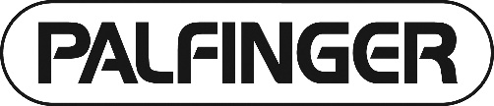
Question Form
for the 33rd Annual General Meeting of
PALFINGER AG, April 7, 2021, 10.00 a.m., Vienna time, 5211 Lengau, Kapellenstrasse 18

IMPORTANT NOTICE: This form does not entitle you to participate in the Annual General Meeting in person.
Please contact your custodian bank and make sure that your shares have been properly registered for participation in the Annual General Meeting by deposit receipt (record date: March 28, 2021).

Questioner (Shareholder)

First name, last name/company name
Street, postal code, place of residence Date of birth/register number
Custody account number Credit institution
E-mail address (by signing this form, you confirm that only the person granting the proxy has access to this e-mail address)

Dear Shareholder,

To enable the Executive Board to properly prepare and answer your questions as quickly as possible, please e-mail your questions to fragen.palfinger@hauptversammlung.at in due time before the Annual General Meeting so that the company receives the question form no later than April 1, 2021.

During the Annual General Meeting, (additional) questions can be e-mailed in text form directly to the following e-mail address: fragen.palfinger@hauptversammlung.at. More specific information is published on the company's website at www.palfinger.ag with respect to the organizational and technical prerequisites for participation under Sec. 3 para. 3 in conjunction with Sec. 2 para. 4 of the COVID-19 Company Law Regulation (COVID-19-GesV) (“Information on Participation”).

Agenda item | Questions

Date | Signature/authorized corporate signature | Signatures of all co-owners, if any

